WOOTTON BASSETT SUNSET SERVICE

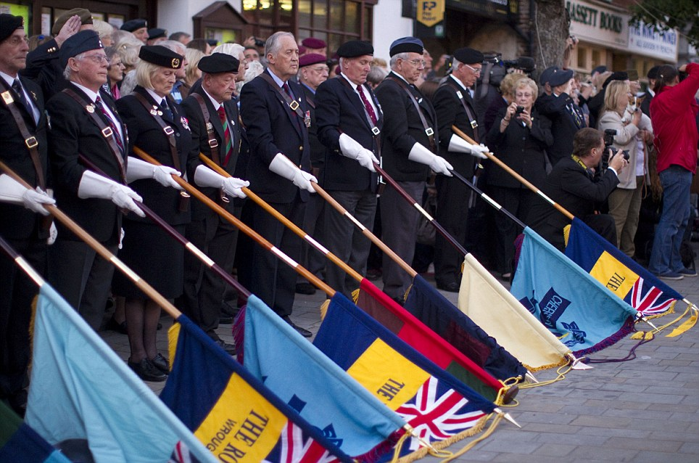
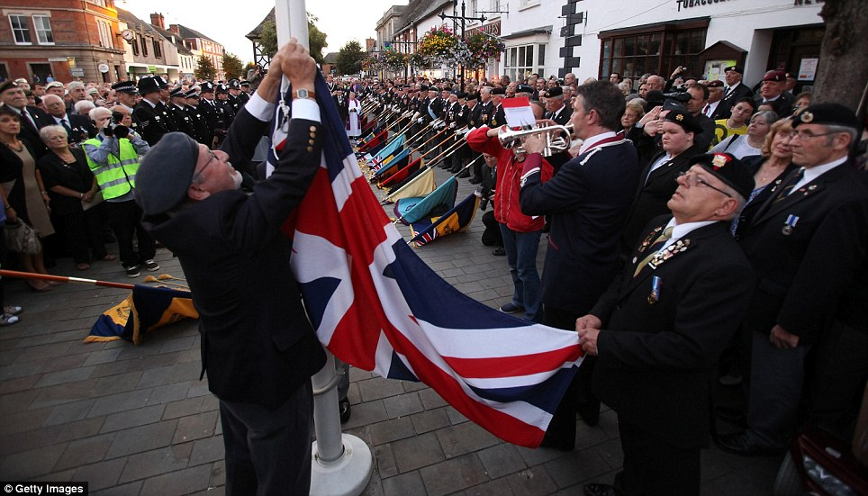
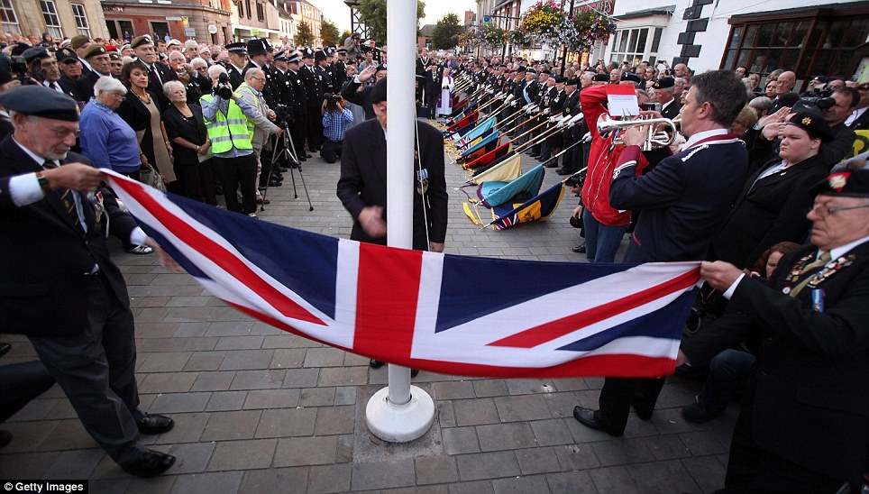

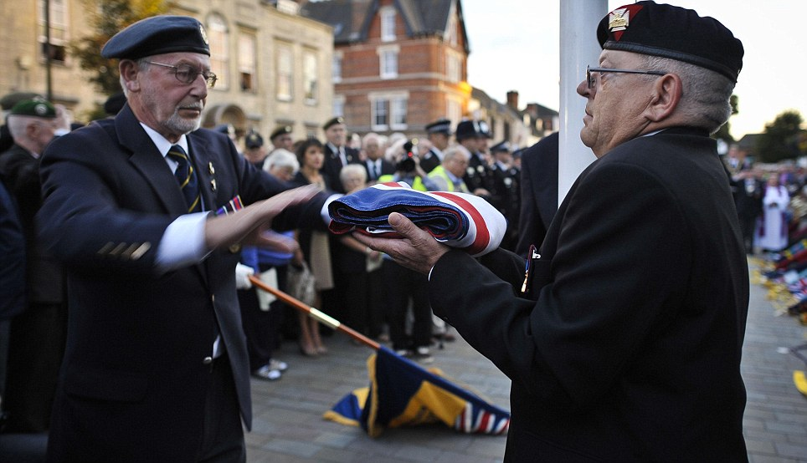

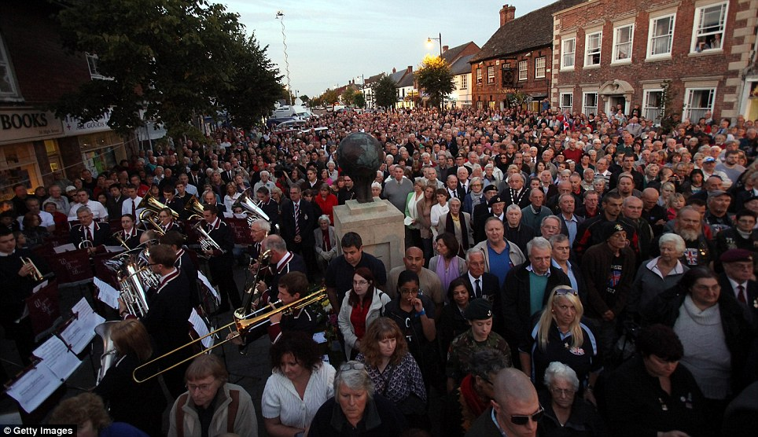

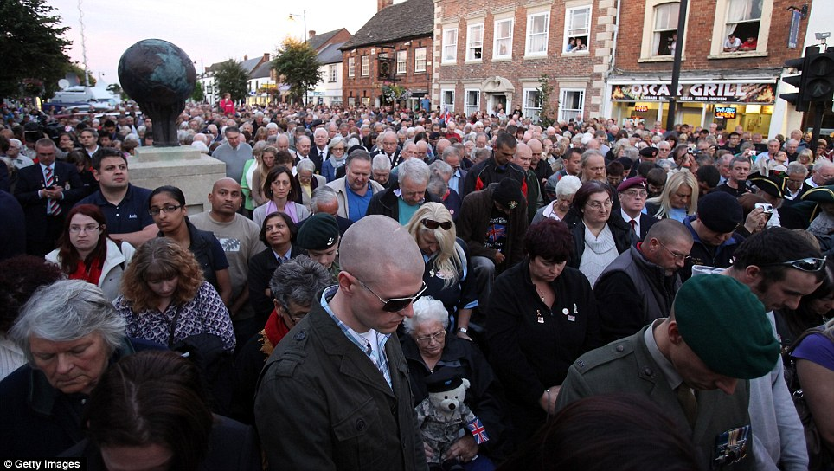

WOOTTON BASSETT SUNSET SERVICE

The Wootton Bassett Sunset Service took place on Wednesday 31st August 2011. As the sun set the people of Wootton Bassett along with over 45 Standards of the associations across the county fell silent for the last time. At 2000hrs the Union flag was lowered for the last time to mark the end of military repatriations thought Wootton Bassett. The Swindon Branch of the REA Standard was paraded by are President George Elliott and Reg Cushion with the Andover Standard, with several members of the branch in the crowds. The Union flag was then blessed before being laid over in St Bartholomews Church over night. It was then handed over the following day to the new memorial garden at RAF Brize Norton were it was raised.

